

**CCIT FLOOR 2 NETWORK INFRASTRUCTURE**

Group 4:

**Kheyral Sutan Dumas**

**Naufal Fauzan Wildani**

**Wygho Sandova Putra Maulana**

Faculty:

**Mr. Tri Agus Riyadi, M.T**

Class:

**2CS1**

**CEP CCIT FACULTY OF ENGINEERING**

**UNIVERSITY OF INDONESIA**

**2024**

**PROJECT INFORMATION**

Project Title : CCIT Floor 2 Network Infrastructure

Batch Code : 2CS1

Start Date : March 21, 2024

End Date : April 18, 2024

Name of Faculty : Mr. Tri Agus Riyadi, S.Kom, MT

Names of Network Administrator :

1. Kheyral Sutan Dumas
2. Naufal Fauzan Wildani
3. Wygho Sandova Putra Maulana



**CERTIFICATE OF ORIGINALITY**

This is to certify that the project report titled "CCIT Floor 2 Network Infrastructure" is an original work completed by Kheyral Sutan Dumas, Naufal Fauzan Wildani, and Wygho Sandova Putra Maulana. This project has been submitted in partial fulfillment of their course requirement at the National Institute of Information Technology (NIIT).

The project report has been prepared under our guidance and supervision, and it is ensured that the work presented in this report is the result of the individual efforts of the aforementioned students. The contents of this report have not been submitted to any other institution or organization for the award of any degree, diploma, or other similar recognition.

Author acknowledge that the ideas, designs, and implementations presented in this project report are the intellectual properties of the students mentioned above. Any use or reproduction of this work must give proper credit to the original authors.

Author hereby endorse the authenticity and originality of the work presented in this project report and confirm that it meets the academic standards and requirements set forth by the National Institute of Information Technology (NIIT).

Coordinator :

Mr. Tri Agus Riyadi, S.Kom, MT

**ACKNOWLEDGEMENT**

Author would like to acknowledge the completion of the insightful paper entitled "CCIT Floor 2 Network Infrastructure." This paper comprehensively discusses the integration of Networking Technology in the functioning of analyzing efficiency, security, and convenience inside the infrastructure.

The contents of this paper provide a detailed overview of potential benefits of Networking Technology. The authors have meticulously examined the various aspects of Network Technology, such as Routing, IP Services, Webserver, and other Network services. Furthermore, the paper explores the challenges associated with the implementation of Networking in CCIT, offering valuable insights for future research and development in this area.

Overall, the paper serves as a significant contribution to the growing body of knowledge on Networking applications in the context of implementing network infrastructure.

Depok, 4 April 2024

Authors

**SYSTEM ANALYSIS**

This paper "CCIT Floor2 Network Infrastructure" delves into the integration of Network Infrastructure. The study aims to research The paper specifically focusing on the infrastructure of CCIT floor 2.

The study aims to research, analyze the network architecture and resources within this particular environment, aiming to understanding its efficiency, reliability, and scalability. By examining the current infrastructure, including routers, switches, cables, and other networking components, the research endeavors to identify potential bottlenecks, vulnerabilities, and areas for improvement. Furthermore, the paper explores emerging technologies and best practices in network design and management, considering factors such as bandwidth requirements, security protocols, and future scalability.

Through rigorous empirical analysis and simulation, the study seeks to propose recommendations and strategies for optimizing the CCIT floor 2 network infrastructure, ensuring seamless connectivity, robust security, and efficient resource utilization.

Ultimately, the paper aspires to suggest a comprehensive framework for designing, implementing, and maintaining network infrastructures tailored to the specific needs and requirements of CCIT floor 2, thereby facilitating enhanced communication, collaboration, and productivity within the academic and professional community.

**NETWORK TOPOLOGY**

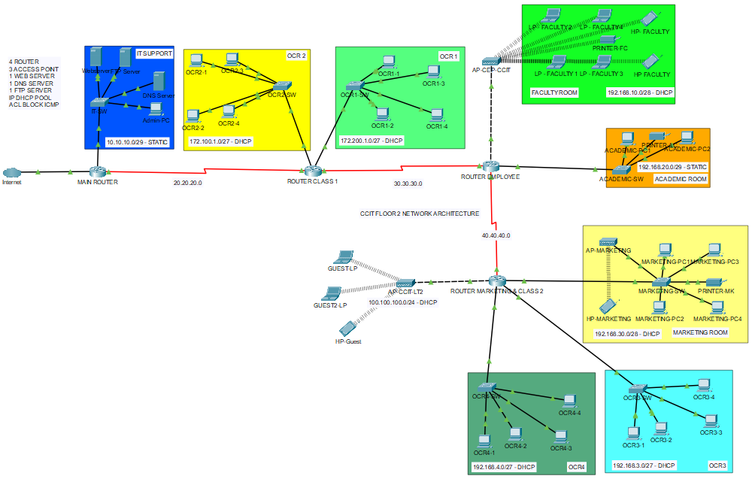

|  |  |  |  |
| --- | --- | --- | --- |
| **SECTION** | **NETWORK ADDRESS** | **SUBNETMASK** | **AVAILABLE HOST** |
| IT SUPPORT | 10.10.10.0 | 255.255.255.248 | 6 |
| OCR 2 | 172.100.1.0 | 255.255.255.224 | 30 |
| OCR 1 | 172.200.1.0 | 255.255.255.224 | 30 |
| FACULTY | 192.168.10.0 | 255.255.255.240 | 14 |
| ACADEMIC | 192.168.20.0 | 255.255.255.248 | 4 |
| MARKETING | 192.168.30.0 | 255.255.255.240 | 14 |
| WIFI MKTING | 192.168.30.0 | 255.255.255.240 | 14 |
| WIFI CCIT LT2 | 100.100.100.0 | 255.255.255.0 | 254 |
| OCR 4 | 192.168.4.0 | 255.255.255.224 | 30 |
| OCR 3 | 192.168.3.0 | 255.255.255.224 | 30 |

**NETWORK DEVICES**

**IT Support**

|  |  |  |  |  |
| --- | --- | --- | --- | --- |
| **Devices** | **Device Name** | **IP Address** | **Gateway** | **Features** |
| Routers PT-Empty | Main-Router | FA 0/0 10.10.10.1/29  SE 0/1  20.20.20.1 | ISP IP | Routing Information Protocol (RIP) |
| Server | Web  DNS  FTP | 10.10.10.2  10.10.10.5  10.10.10.3 | 10.10.10.1 | - Webserver  - DNS  - FTP |
| Switch PT-Empty | IT-SW | - | - | - |
| PC | Admin-PC | 10.10.10.4 | 10.10.10.1 | - Browser  - CMD |

**OCR 2**

|  |  |  |  |  |
| --- | --- | --- | --- | --- |
| **Devices** | **Device Name** | **IP Address** | **Gateway** | **Features** |
| Routers PT-Empty | Router-Class1 | FA 2/0  172.100.1.1/27  SE 1/0  30.30.30.1 | SE 0/0  20.20.20.2 | - DHCP Pool  - Access Control List  - RIP |
| Switch PT-Empty | OCR2-SW | - | - | - |
| PC | OCR2-1 s/d 4 | 172.100.1.0/27  (DHCP) | 172.100.1.1 | - Browser  - CMD |

**NETWORK DEVICES**

**OCR 1**

|  |  |  |  |  |
| --- | --- | --- | --- | --- |
| **Devices** | **Device Name** | **IP Address** | **Gateway** | **Features** |
| Routers PT-Empty | Router-Class1 | FA 3/0  172.200.1.1/27  SE 1/0  30.30.30.1 | SE 0/0  20.20.20.2 | - RIP  - DHCP Pool  - ACL |
| Switch PT-Empty | OCR1-SW | - | - | - |
| PC | OCR1-1 s/d 4 | 172.200.1.0/27  (DHCP) | 172.200.1.1 | - Browser  - CMD |

**Faculty**

|  |  |  |  |  |
| --- | --- | --- | --- | --- |
| **Devices** | **Device Name** | **IP Address** | **Gateway** | **Features** |
| Routers PT-Empty | Router-Employee | FA 2/0  192.168.10.1/28  SE 1/0  40.40.40.1 | SE 0/0  30.30.30.2 | - RIP  - DHCP Pool  - ACL |
| Access Point-PT | CCIT-Faculty | - | 192.168.10.1 | - |
| Laptop | LP-1 s/d 4 | 192.168.10.0/28  (DHCP) | 192.168.10.1 | - Browser  - CMD  - Wireless |

**NETWORK DEVICES**

**Academic**

|  |  |  |  |  |
| --- | --- | --- | --- | --- |
| **Devices** | **Device Name** | **IP Address** | **Gateway** | **Features** |
| Routers PT-Empty | Router-Employee | FA 3/0  192.168.20.1/29  SE 0/1  40.40.40.1/8 | SE 0/0  30.30.30.2/8 | - DHCP Pool  - ACL  - RIP |
| Switch  PT-Empty | Academic-SW | - | - | - |
| PC | Academic PC 1 s/d 2 | 192.168.20.2/29  192.168.20.3/29 | FA 3/0  192.168.20.1 | - Browser  - CMD |
| Printer | Printer-AC | 192.168.20.4/29 | 192.168.20.1 | - Wireless |

**Guest**

|  |  |  |  |  |
| --- | --- | --- | --- | --- |
| **Devices** | **Device Name** | **IP Address** | **Gateway** | **Features** |
| Routers PT-Empty | Router-Marketing  &Class 2 | FA 1/0  100.100.100.1/24 | SE 0/0  40.40.40.2/8 | - DHCP Pool  - ACL  - RIP |
| Access Point-PT | CCIT-LT2 | - | 100.100.100.1 | - Wireless |
| Laptop | LP-Guest 1 s/d 2 | 100.100.100.0/24 | 100.100.100.1 | - Browser  - CMD  -Wireless |
| Handphone | HP-Guest | 100.100.100.0/24 | 100.100.100.1 | - Wireless |

**NETWORK DEVICES**

**Marketing**

|  |  |  |  |  |
| --- | --- | --- | --- | --- |
| **Devices** | **Device Name** | **IP Address** | **Gateway** | **Features** |
| Routers PT-Empty | Router-Marketing  &Class 2 | FA 2/0  192.168.30.1/28 | SE 0/0  40.40.40.2/8 | - DHCP Pool  - ACL  - RIP |
| Switch  PT-Empty | Marketing-SW | - | - | - |
| Access Point-PT | CCIT-Marketing | - | 192.168.30.1 | - Wireless |
| PC | Marketing-PC 1 s/d 4 | 192.168.30.0/28 | 192.168.30.1 | - Browser  - CMD  -Wireless |
| Printer | Printer-MK | 192.168.30.0/28 | 192.168.30.1 | - Wireless |
| Handphone | HP-Guest | 192.168.30.0/28 | 192.168.30.1 | - Wireless |

**NETWORK DEVICES**

**OCR 4**

|  |  |  |  |  |
| --- | --- | --- | --- | --- |
| **Devices** | **Device Name** | **IP Address** | **Gateway** | **Features** |
| Routers PT-Empty | Router-Marketing  &Class 2 | FA 3/0  192.168.4.1/27 | SE 0/0  40.40.40.2/8 | - DHCP Pool  - ACL  - RIP |
| Switch PT-Empty | OCR1-SW | - | - | - |
| PC | OCR1-1 s/d 4 | 192.168.4.0/27  (DHCP) | 192.168.4.1 | - Browser  - CMD |

**OCR 3**

|  |  |  |  |  |
| --- | --- | --- | --- | --- |
| **Devices** | **Device Name** | **IP Address** | **Gateway** | **Features** |
| Routers PT-Empty | Router-Marketing  &Class 2 | FA 4/0  192.168.3.1/27 | SE 0/0  40.40.40.2/8 | - DHCP Pool  - ACL  - RIP |
| Switch PT-Empty | OCR1-SW | - | - | - |
| PC | OCR1-1 s/d 4 | 192.168.3.0/27  (DHCP) | 192.168.3.1 | - Browser  - CMD |

**CONFIGURATION**

1. **Setting up interfaces on PT-Empty Devices**

Interfaces should be installed on each PT-Empty device to establish connectivity within the network topology.

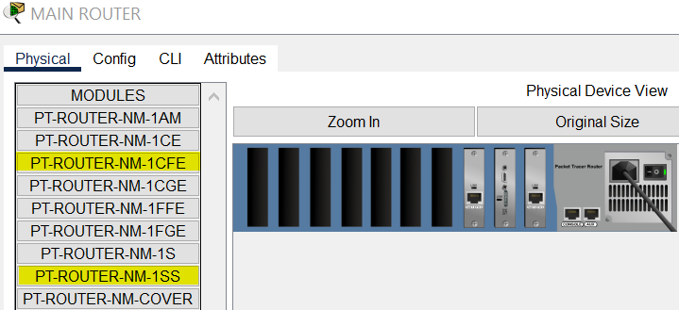

The Fast Ethernet interface should be equipped with module 1CFE, while the serial interface should utilize module 1SS for optimal performance and compatibility.

This procedure should be replicated across all routers, with necessary adjustments made to accommodate the specific port and interface requirements dictated by the network topology.

**CONFIGURATION**

Similar configuration steps should be undertaken for switches, but switches will only employ module 1CFE for interface configuration.

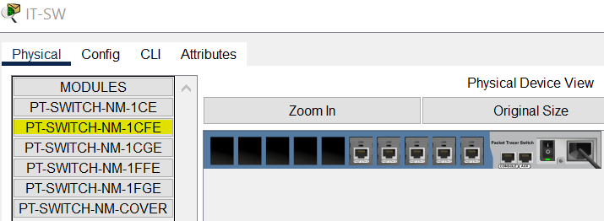

Next, establish connections using cables based on the following criteria:

|  |  |
| --- | --- |
| **DEVICES** | **CABLES** |
| Router to Router | Serial Interfaces |
| Router to Switch | Straight Trough – Fast Ethernet |
| Router to Access Point | Cross Over – Fast Ethernet |
| Switch to End-Devices | Straight Trough – Fast Ethernet |
| Switch to Server | Straight Trough – Fast Ethernet |
| Switch to Access Point | Straight Trough – Fast Ethernet |

**CONFIGURATION**

1. **Configuration within Routers**

Configuration with the routers will be initiated first. The Command Line Interface (CLI) can be accessed by opening the router interface. All settings within this router should be noted and retained. Adjust interface configurations according to the cable topology specific to your devices. IP Address configuration should be prioritized initially.

Follow the command bellow in Command Line Interface. After this step is to repeat the main router's configurations for routers with DHCP clients, as well as to set up extra DHCP settings.

|  |
| --- |
| **MAIN ROUTER (STATIC)** |
| // **Enabling router privileges mode**  Router> enable  Router# configure terminal  **// Setup router password**  Router(config)# enable password routerpassword1  **// Setup IP Network IT Support**  Router(config)# interface fastethernet 0/0  Router(config-if)# ip address 10.10.10.1 255.255.255.248  Router(config-if)# no shutdown  **// Setup IP Network Serial Interfaces**  Router(config)# interface serial 1/0  Router(config-if)# ip address 20.20.20.1 255.0.0.0  Router(config-if)# no shutdown |

|  |
| --- |
| **ROUTER CLASS 1 (DHCP)** |
| **// Enabling router privileges mode**  Router> enable  Router# configure terminal  **// Setup router password**  Router(config)# enable password routerpassword2  **// Setup IP Network OCR2 and OCR3**  Router(config)# interface fastethernet 2/0  Router(config-if)# ip address 172.100.1.1 255.255.255.224  Router(config-if)# no shutdown  Router(config-if)# exit  Router(config)# interface fastethernet 3/0  Router(config-if)# ip address 172.200.1.1 255.255.255.224  Router(config-if)# no shutdown  **// Setup IP Network Serial Interfaces**  Router(config)# interface serial 0/0  Router(config-if)# ip address 20.20.20.2 255.0.0.0  Router(config-if)# no shutdown  Router(config)# exit  Router(config)# interface serial 1/0  Router(config-if)# ip address 30.30.30.1 255.0.0.0  Router(config-if)# no shutdown  **//Setup DHCP Pool OCR2 and OCR1**  Router(config)# ip dhcp pool OCR2  Router(dhcp-config)# network 172.100.1.0 255.255.255.224  Router(dhcp-config)# default-router 172.100.1.1  Router(dhcp-config)# dns-server 10.10.10.5  Router(dhcp-config)# exit  Router(config)# ip dhcp pool OCR1  Router(dhcp-config)# network 172.200.1.0 255.255.255.224  Router(dhcp-config)# default-router 172.200.1.1  Router(dhcp-config)# dns-server 10.10.10.5 |

**CONFIGURATION**

**CONFIGURATION**

|  |
| --- |
| **ROUTER EMPLOYEE (DHCP & STATIC)** |
| **// Enabling router privileges mode**  Router> enable  Router# configure terminal  **// Setup router password**  Router(config)# enable password routerpassword3  **// Setup IP Network FACULTY and ACADEMIC**  Router(config)# interface fastethernet 2/0  Router(config-if)# ip address 192.168.10.1 255.255.255.224  Router(config-if)# no shutdown  Router(config-if)# exit  Router(config)# interface fastethernet 3/0  Router(config-if)# ip address 192.168.20.1 255.255.255.224  Router(config-if)# no shutdown  **// Setup IP Network Serial Interfaces**  Router(config)# interface serial 0/0  Router(config-if)# ip address 30.30.30.2 255.0.0.0  Router(config-if)# no shutdown  Router(config)# interface serial 1/0  Router(config-if)# ip address 40.40.40.1 255.0.0.0  Router(config-if)# no shutdown  **//Setup DHCP Pool FACULTY**  Router(config)# ip dhcp pool FACULTY  Router(dhcp-config)# network 192.168.10.0 255.255.255.240  Router(dhcp-config)# default-router 192.168.10.1  Router(dhcp-config)# dns-server 10.10.10.5  **// ACADEMIC IP is Static** |

**CONFIGURATION**

|  |
| --- |
| **ROUTER MARKETING & CLASS 2 (DHCP)** |
| **// Enabling router privileges mode**  Router> enable  Router# configure terminal  **// Setup router password**  Router(config)# enable password routerpassword4  **// Setup IP Network MARKETING & WiFi, GUEST, OCR4, and OCR3**  Router(config)# interface fastethernet 2/0  Router(config-if)# ip address 192.168.30.1 255.255.255.240  Router(config-if)# no shutdown  Router(config-if)# exit  Router(config)# interface fastethernet 1/0  Router(config-if)# ip address 100.100.100.1 255.255.255.0  Router(config-if)# no shutdown  Router(config-if)# exit  Router(config)# interface fastethernet 3/0  Router(config-if)# ip address 192.168.4.1 255.255.255.224  Router(config-if)# no shutdown  Router(config-if)# exit  Router(config)# interface fastethernet 4/0  Router(config-if)# ip address 192.168.3.1 255.255.255.224  Router(config-if)# no shutdown  **// Setup IP Network Serial Interfaces**  Router(config)# interface serial 0/0  Router(config-if)# ip address 40.40.0.2 255.0.0.0  Router(config-if)# no shutdown |

**CONFIGURATION**

|  |
| --- |
| **// Setup DHCP Pool for MARKETING & WiFi, GUEST, OCR4, OCR3**  Router(config)# ip dhcp pool MARKETING  Router(dhcp-config)# network 192.168.30.0 255.255.255.240  Router(dhcp-config)# default-router 192.168.30.1  Router(dhcp-config)# dns-server 10.10.10.5  Router(dhcp-config)# exit  Router(config)# ip dhcp pool CCIT-LT2  Router(dhcp-config)# network 100.100.100.0 255.255.255.0  Router(dhcp-config)# default-router 100.100.100.1  Router(dhcp-config)# dns-server 10.10.10.5  Router(dhcp-config)# exit  Router(config)# ip dhcp pool OCR4  Router(dhcp-config)# network 192.168.4.0 255.255.255.224  Router(dhcp-config)# default-router 192.168.4.1  Router(dhcp-config)# dns-server 10.10.10.5  Router(dhcp-config)# exit  Router(config)# ip dhcp pool OCR3  Router(dhcp-config)# network 192.168.3.0 255.255.255.224  Router(dhcp-config)# default-router 192.168.3.1  Router(dhcp-config)# dns-server 10.10.10.5 |

**CONFIGURATION**

After the IP addresses have been assigned, routing will be configured, which involves creating paths to connect all of the different networks using the dynamic Routing Information Protocol (RIP), starting with the main router and continuing to the marketing router.

The rules of RIP routing, put the source network (the section IP that has been assigned) and the paths network (the IP that has been assigned into the serial interface).

**Main Router**

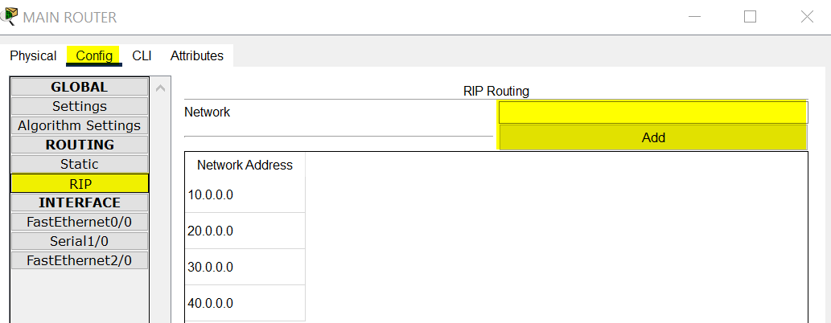

**Router Class 1**

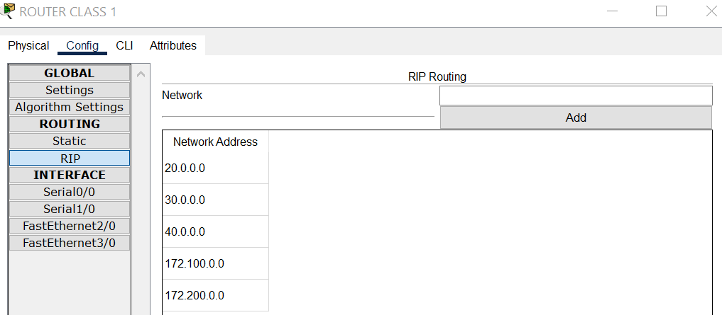

**CONFIGURATION**

**Router Employee**

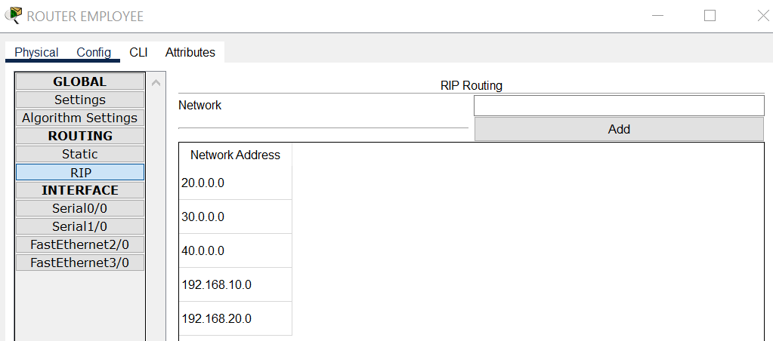

**Router Marketing & Class 2**

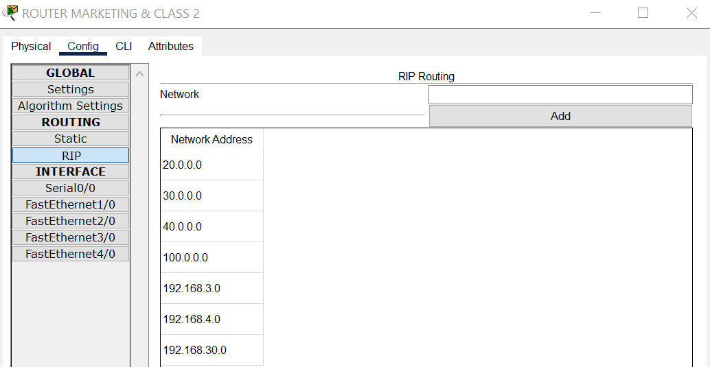

**CONFIGURATION**

1. **Setting up Access Point for Faculty, Guest & Marketing**

Setting up the access point for both CCIT guests and Faculty will be the next step, Don’t forget to turn on port 0 also.

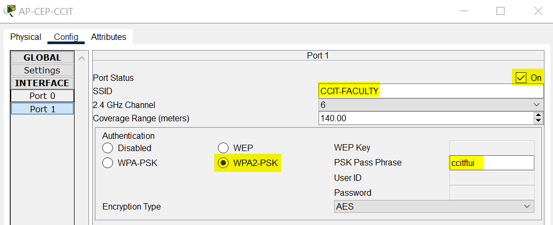

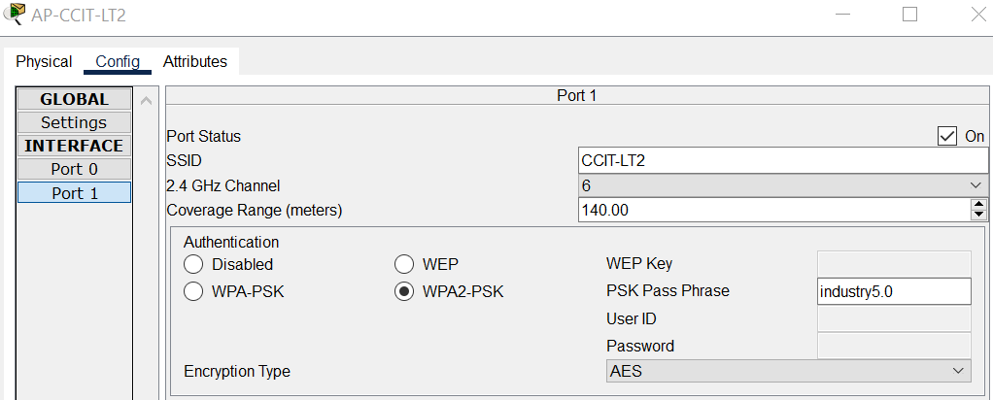

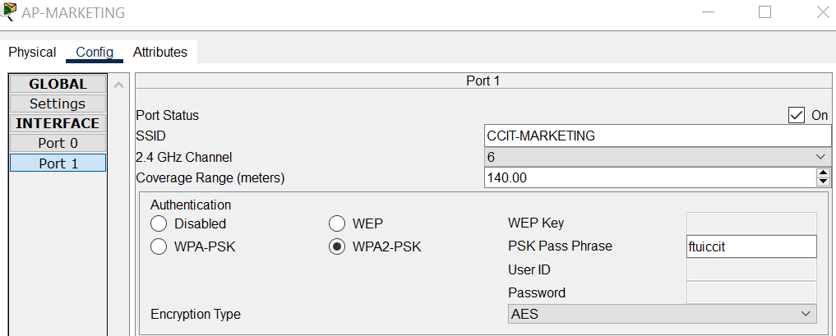

**CONFIGURATION**

1. **Server Configuration**

All server services, including web, DNS, and FTP servers, will now be set up, It should be noted that modifications within index.html files are permissible.

In the DNS server setup, names for web domain can be inputted, along with the address of web server (which also DNS and FTP will be set up later along with end devices), and then the "add" button can be pressed.

For the FTP server configuration, the process is similar to setting up the DNS and web server. The key difference lies in the services offered. Here, admin can input usernames and passwords for the server, along with their respective permissions.

**Webserver**

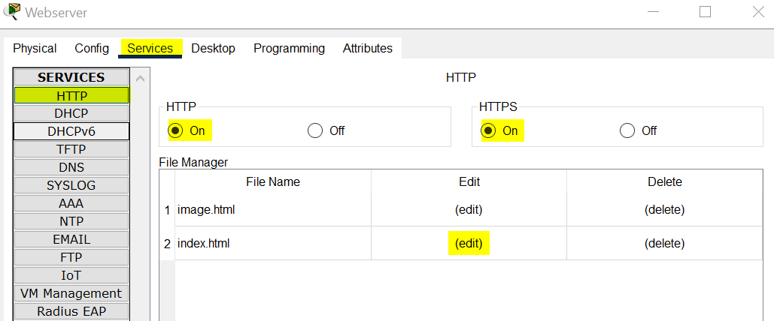

**CONFIGURATION**

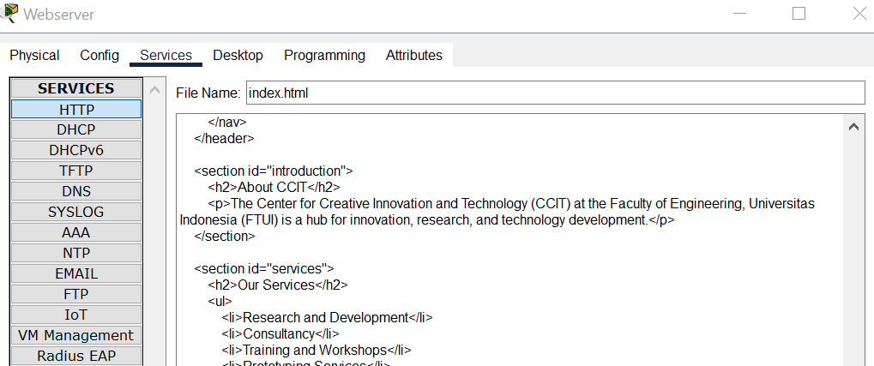

**DNS Server**

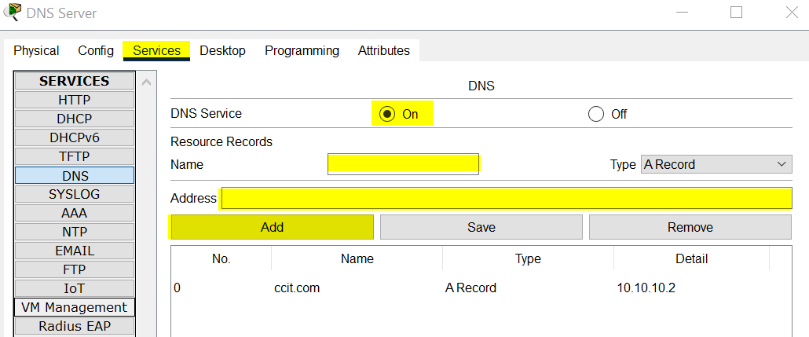

**FTP Server**

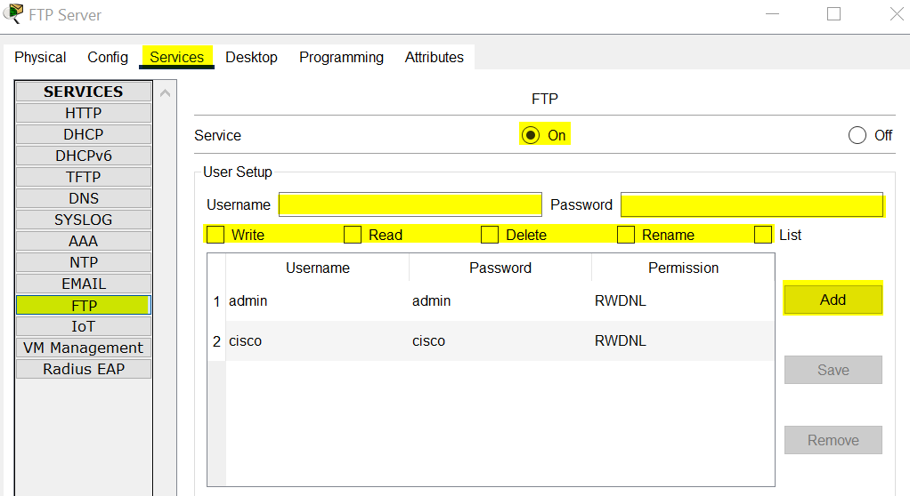

**CONFIGURATION**

1. **Security Configuration with Access Control List**

The final configuration involves implementing a security protocol using ACL (Access Control List). Specifically, blocking incoming ICMP protocol to the server, preventing any potential DoS attacks on the web server from within the CCIT network, this setting will be initiated to routers bellow.

|  |
| --- |
| **ROUTER CLASS 1** |
| // **Enabling router privileges mode**  Router> enable  Router# configure terminal  **// Setup ACL on Port 2/0 and 3/0**  Router(config)# access-list 100 deny icmp 172.100.1.0 0.0.0.31 host 10.10.10.2  Router(config)# access-list 100 permit ip any any  Router(config)# interface 2/0  Router(config-if)# ip access-group 100 in  Router(config)-if# exit  Router(config)# access-list 101 deny icmp 172.200.1.0 0.0.0.31 host 10.10.10.2  Router(config)# access-list 101 permit ip any any  Router(config)# interface 3/0  Router(config-if)# ip access-group 101 in |

**CONFIGURATION**

|  |
| --- |
| **ROUTER EMPLOYEE** |
| // **Enabling router privileges mode**  Router> enable  Router# configure terminal  **// Setup ACL on Port 2/0 and 3/0**  Router(config)# access-list 100 deny icmp 192.168.10.0 0.0.0.15 host 10.10.10.2  Router(config)# access-list 100 permit ip any any  Router(config)# interface 2/0  Router(config-if)# ip access-group 100 in  Router(config)-if# exit  Router(config)# access-list 101 deny icmp 192.168.20.0 0.0.0.7 host 10.10.10.2  Router(config)# access-list 101 permit ip any any  Router(config)# interface 3/0  Router(config-if)# ip access-group 101 in |

**CONFIGURATION**

|  |
| --- |
| **ROUTER MARKETING & CLASS 2** |
| // **Enabling router privileges mode**  Router> enable  Router# configure terminal  **// Setup ACL on Port 2/0, 1/0, 3/0 and 4/0**  Router(config)# access-list 100 deny icmp 192.168.30.0 0.0.0.15 host 10.10.10.2  Router(config)# access-list 100 permit ip any any  Router(config)# interface 2/0  Router(config-if)# ip access-group 100 in  Router(config)-if# exit  Router(config)# access-list 101 deny icmp 100.100.100.0 0.0.0.255 host 10.10.10.2  Router(config)# access-list 101 permit ip any any  Router(config)# interface 1/0  Router(config-if)# ip access-group 101 in  Router(config)-if# exit  Router(config)# access-list 102 deny icmp 192.168.4.0 0.0.0.31 host 10.10.10.2  Router(config)# access-list 102 permit ip any any  Router(config)# interface 3/0  Router(config-if)# ip access-group 102 in  Router(config)-if# exit  Router(config)# access-list 103 deny icmp 192.168.3.0 0.0.0.31 host 10.10.10.2  Router(config)# access-list 103 permit ip any any  Router(config)# interface 4/0  Router(config-if)# ip access-group 103 in |

**CONFIGURATION**

1. **End-Devices & Server setup**

Now it's time to configure the end devices. Configuring end devices involves simply changing the IP mode in each device and adjusting their network settings using either static or DHCP by going to desktop and click on IP Configuration.

In static networks, it's important to designate the gateway IP as the IP address of the router interface leading into the network. For example, if the network's IT section is received through interface 0/0, that interface's IP should be used as the gateway IP.

**IT Support (Static)**

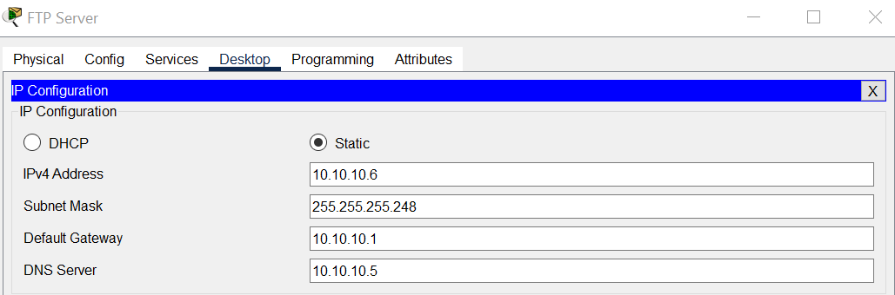

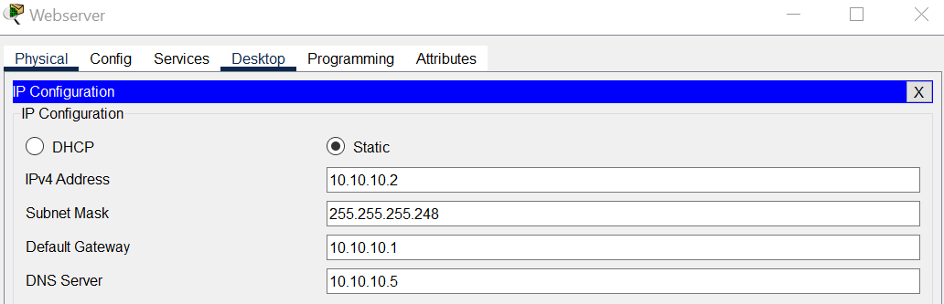

**CONFIGURATION**

The DNS IP should be adjusted to match the one set in the DHCP pool setup otherwise, the DNS won't align with the network, causing the web server to be inaccessible through the domain name.

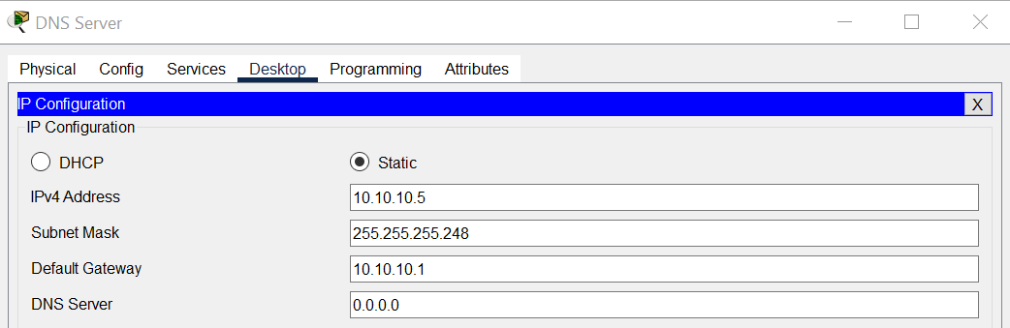

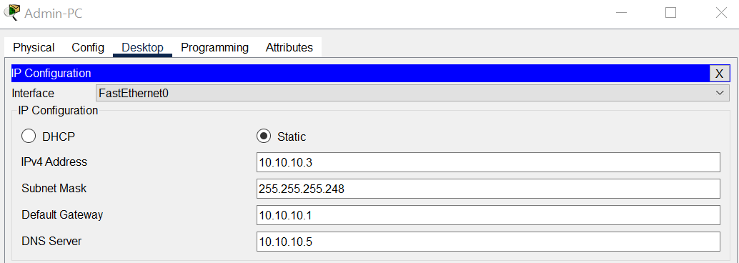

Additionally, for addresses within the network, options are limited to 2-6 due to the subnet's capacity of only allowing 6 hosts, with 1 already allocated to interface 0/0.

**CONFIGURATION**

**OCR1 & OCR2 (DHCP)**

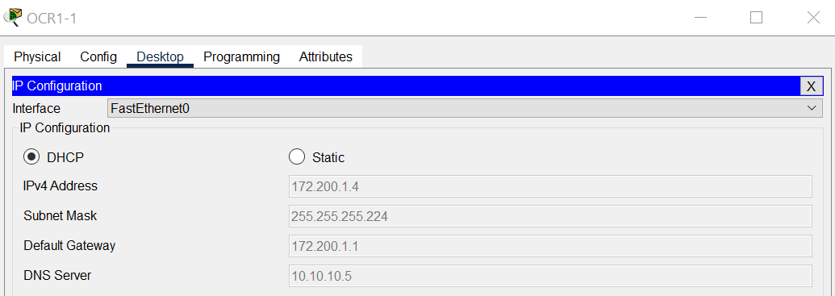

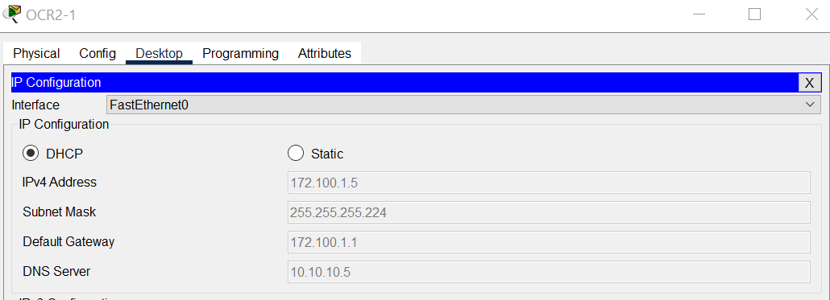

**Academic (Static)**

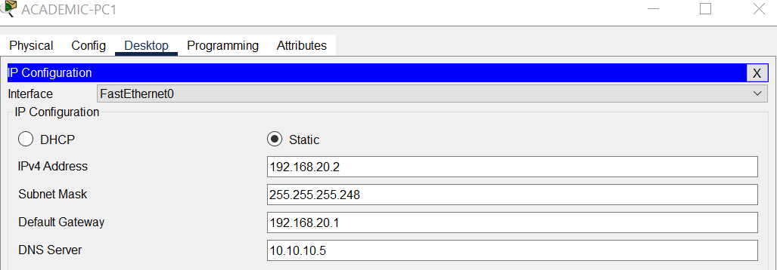

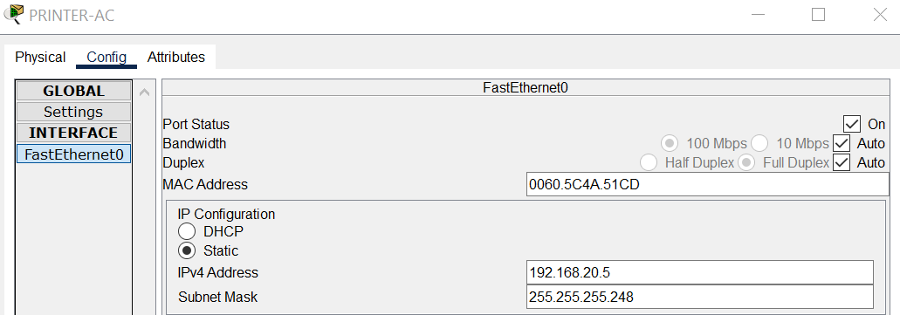

**CONFIGURATION**

**Marketing (DHCP)**

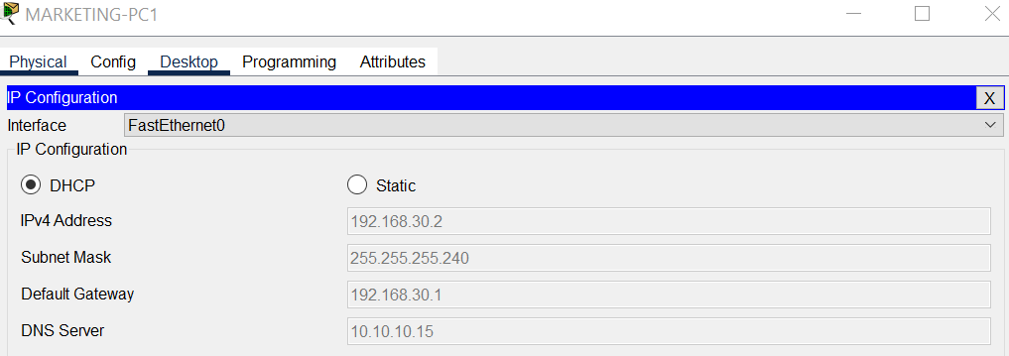

**OCR 3 & OCR 4 (DHCP)**

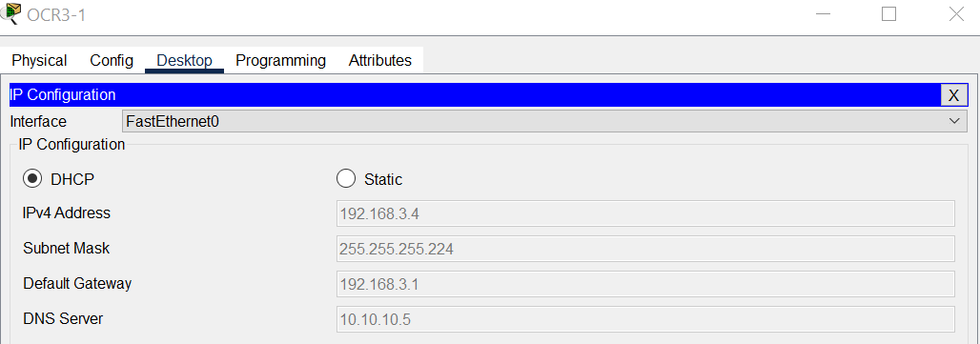

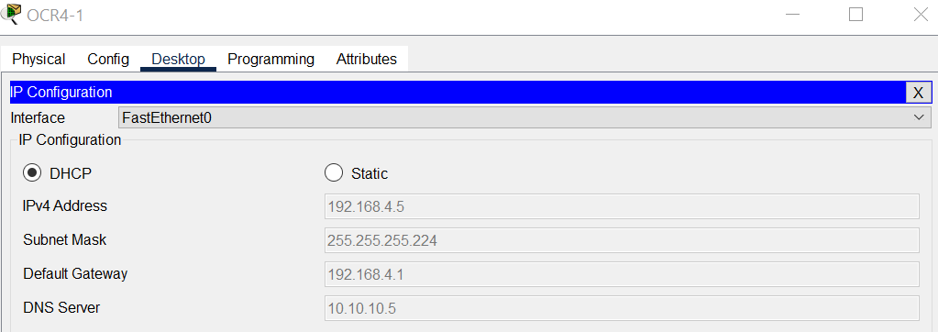

**CONFIGURATION**

To configure the wireless network, the initial step involves changing the interface from cable to wireless.

**Faculty & Guest (Wireless DHCP)**

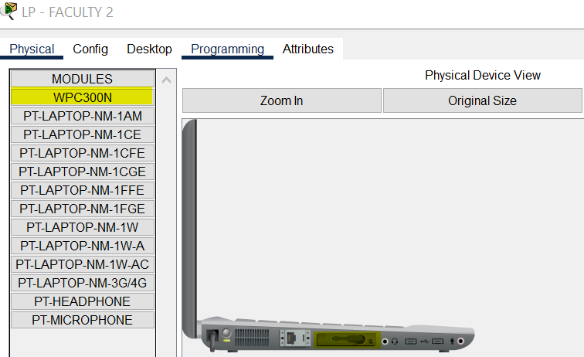

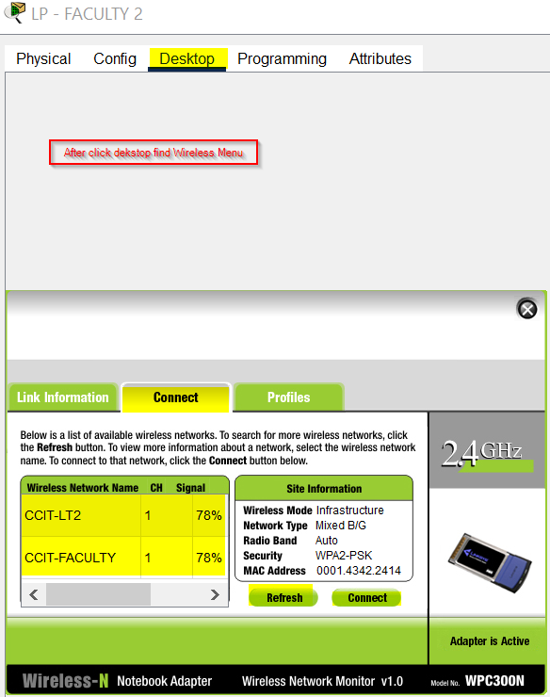

**SIMULATION**

1. **Connection Testing**

**IT Support to all Class**

ICMP Testing

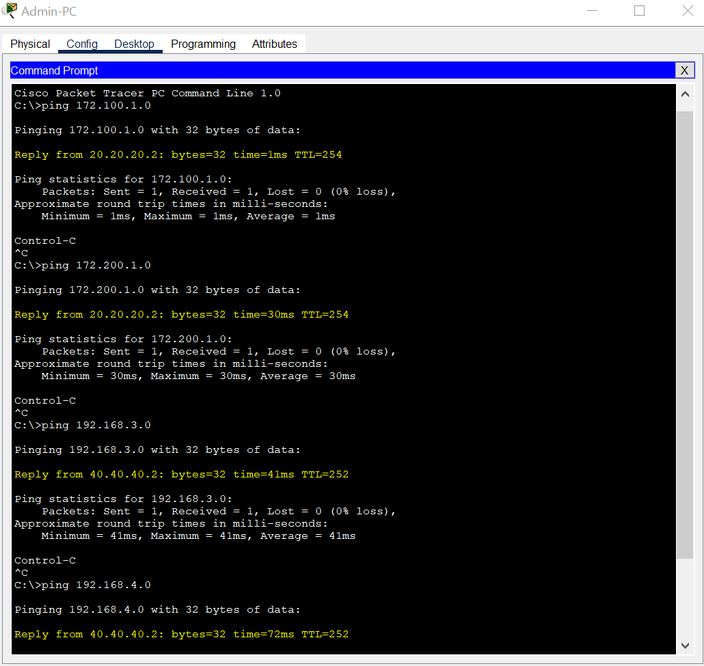

**SIMULATION**

**IT Support to all non Class**

ICMP Testing

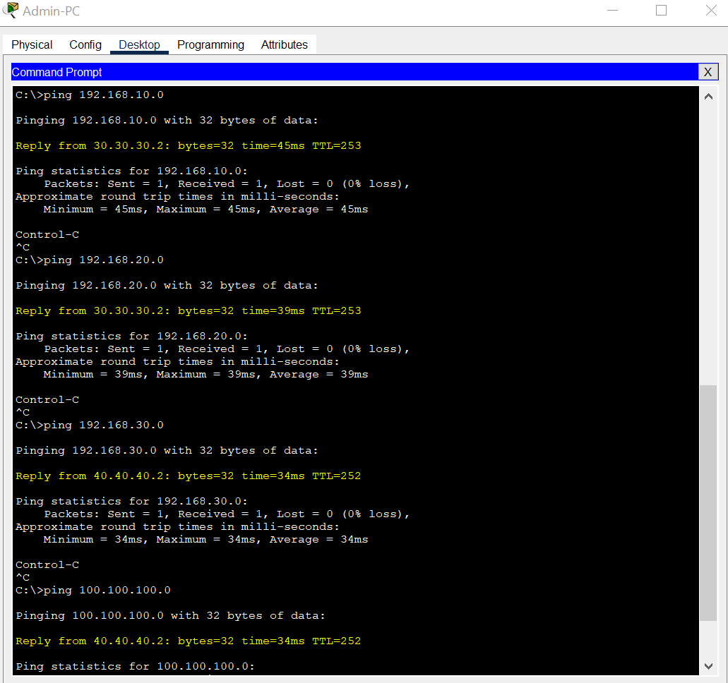

**SIMULATION**

1. **Server Testing**

**DNS & Webserver**

DNS and web server functionality will be tested by simply navigating to the desktop and entering the domain name, which is ccit.com.

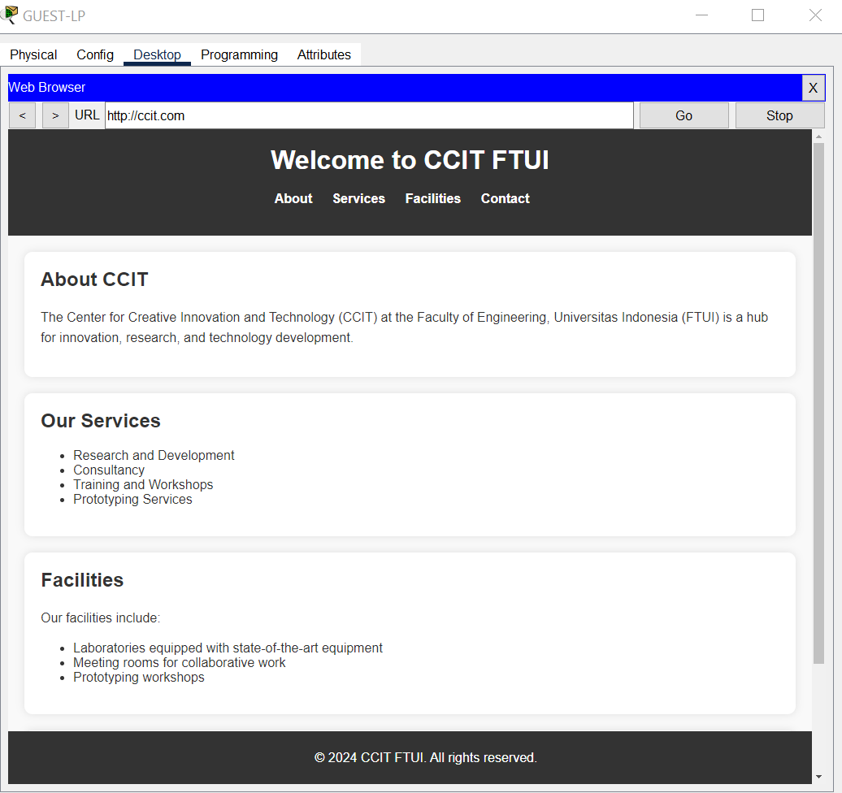

**SIMULATION**

**FTP Server**

Before attempting to access the server, example files will be created for later distribution to other networks.

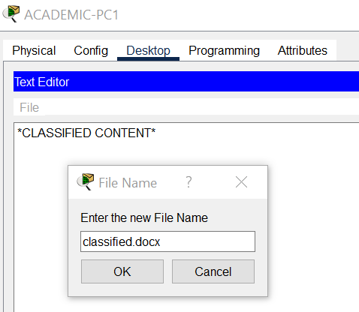

Next, these files will be uploaded to the server, enabling access for other networks.

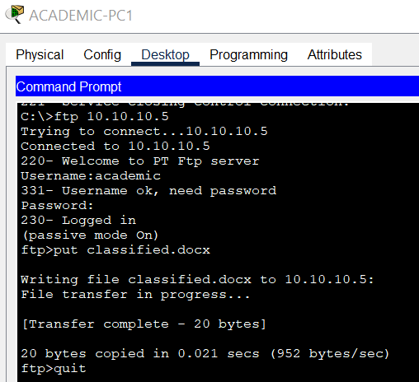

**SIMULATION**

"Classified.docx" will be accessed in another network using the FTP server.

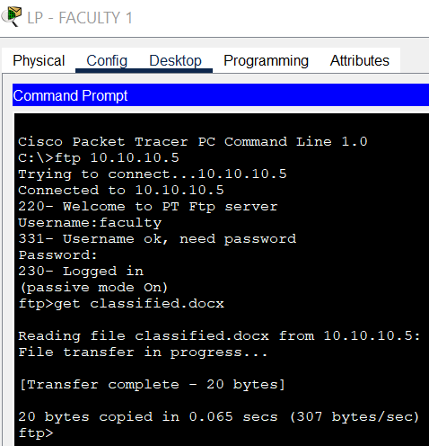

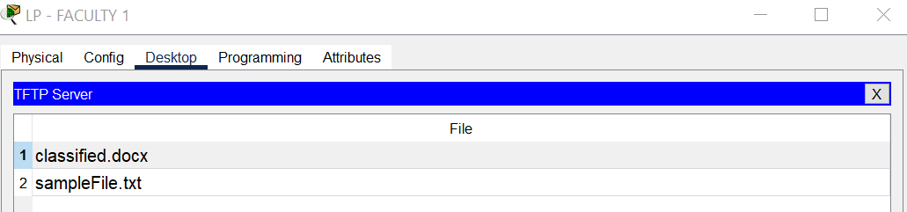

**SIMULATION**

1. **Security Testing**

The security scenario primarily involves implementing ACL to prevent the ICMP protocol from reaching the web server.

**Guest ICMP**

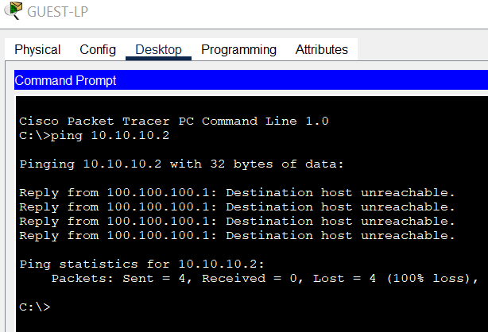

**Class ICMP**

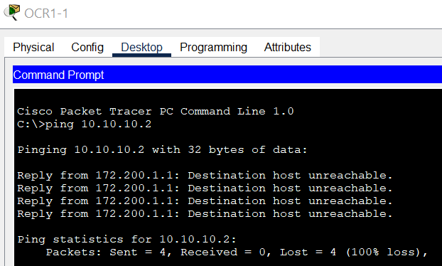

**REQUIREMENTS**

**Hardware** :

1. Lenovo V14 G2

**Operating System** :

1. Windows 10 64-bit

**Software** :

1. Cisco Packet Tracer
2. Ms. Word
3. Google Chrome

|  |  |  |
| --- | --- | --- |
| **PROJECT FILE DETAILS** | | |
| No | Filename | Remarks |
| 1 | 2CS1 Project 1.pdf | Microsoft Words contain research paper about the project |
| 2 | ccitnetworks.pkt | Packet Tracer file contains the network simulation |
| 3 | Project 1 Presentation.pptx | Presentation file |